Stage 4 – Enhanced Practice Makes Perfect
COURSE DESIGNER: Rocky Perillo
SCORING: Comstock 30 rounds.
TARGETS: 15 cardboard targets
SCORED HITS: 2 Best hits per carboard will be scored.

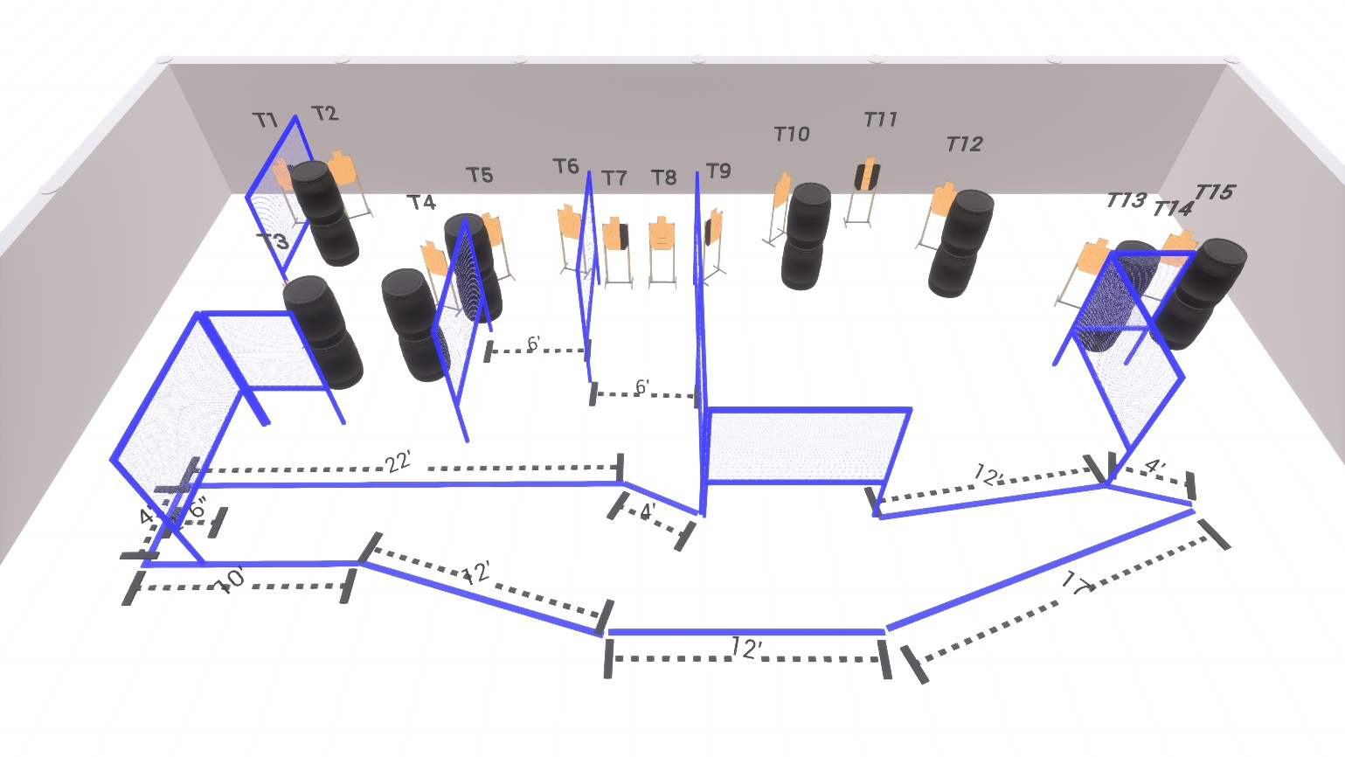

Written Stage Briefing:

Stage 4 – Enhanced Practice Makes Perfect - is a 30 round, 150 point, Comstock Course. There are 15 cardboard targets.

Starting anywhere inside the shooting area.
Handgun is loaded and holstered, wrists below belt.
PCC is loaded held in both hands, stock on belt.

On the audible start signal, engage targets from within the shooting area.

USPSA / NROI Range Commands:
- Make Ready
- Are you ready?
- Standby
- If finished, unload and show clear
- If clear, hammer down and holster (Handgun)
If clear, hammer down and flag (PCC)
If clear, cylinder closed and holster (Revolver)
- Range is clear

Setup Notes:
12 Single Wall Stands
4 Double Wall Stands
8 Full Walls
2 Half Walls
15 Target stands / 30 target sticks
16+ Barrels
